26) Aim: Design Turing Machine using simulator to accept the input string for even length Palindrome.

Diagram:

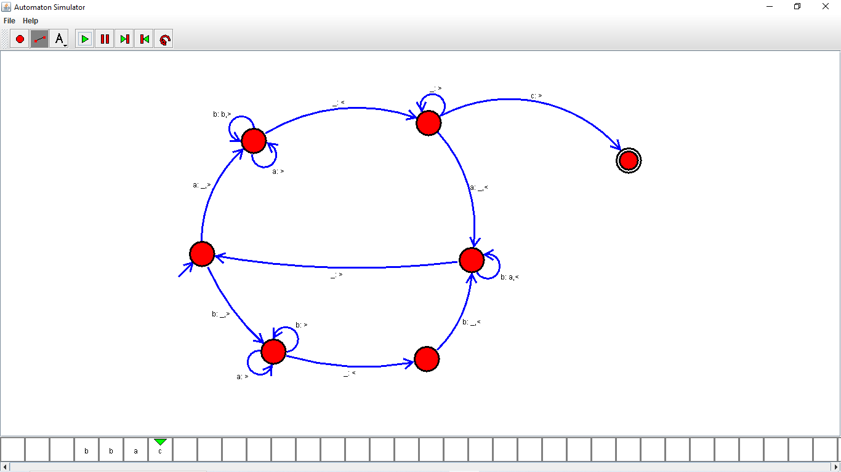

Result:

Successfully executed Turing Machine using simulator to accept the input string for even length Palindrome.